APPENDIX C

Proof of identity (5.5)

Consider the Lagrangian for an electron confined to the x–y plane in the presence of a steady, perpendicular magnetic flux B, and an electric field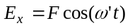, given by

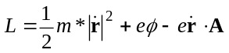, 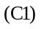

whereis the electron position vector,is the magnetic vector potential and is the electric scalar potential. The corresponding Hamiltonian is given by

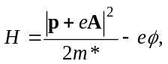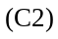

where

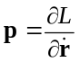, 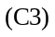

is the conjugate momentum [6].
Expanding (C2) and ignoring the term involving 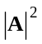, which contributes only to transition rates involving the exchange of two photons [8], we obtain

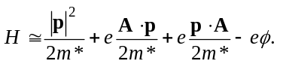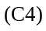

Expressions forandare given by

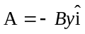, 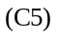

and

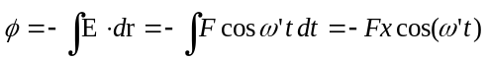, 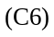

where the arbitrary integration constant has been set to zero for simplicity.
Quantising the Hamiltonian (C4), we obtain

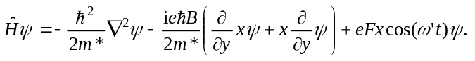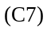

for an arbitrary electron state.

The commutator of this Hamiltonian with the position operatoris given by

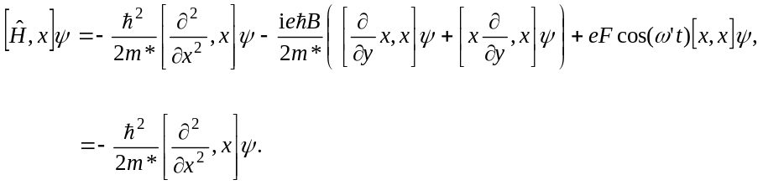

Now consider the matrix element of (C8) using the electron energy eigenstates 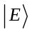and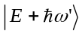, given by

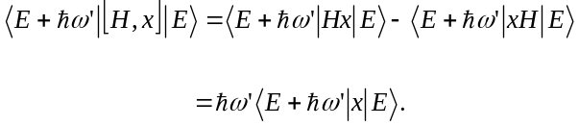

Then using (C8) and (C9), together with the identities
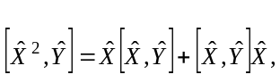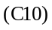

and

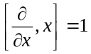, 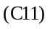

we obtain

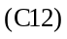

which simplifies to

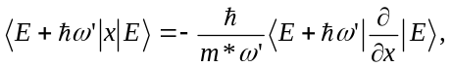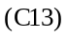

as required.

